"Ladakh – Journey Beyond the Himalayas”
(5N/6D)

Discover the mesmerizing beauty of Ladakh on this unforgettable 6 Days / 5 Nights journey through the majestic Himalayas. Explore the vibrant town of Leh, the breathtaking Nubra Valley, and the world-famous Pangong Lake, surrounded by dramatic mountain landscapes. Cross the legendary Khardung La Pass and Chang La Pass, among the highest motorable roads in the world. Visit ancient monasteries, witness the spectacular confluence of the Indus and Zanskar Rivers, and experience the unique charm of Ladakh's high-altitude desert.

Enjoy a camel ride across the sand dunes of Hunder and admire the ever-changing blue waters of Pangong Lake. Perfect for families, couples, adventure enthusiasts, and nature lovers, this itinerary offers an extraordinary blend of adventure, culture, and unforgettable Himalayan landscapes.

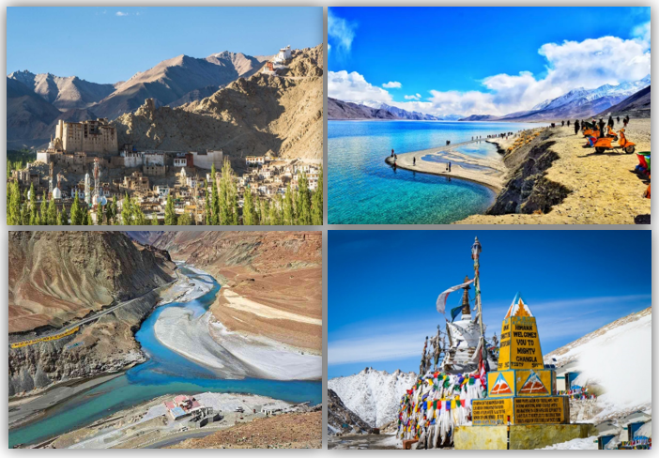

We wish you a happy, safe and unforgettable journey with us
Detailed Itinerary
Day 1: Arrival in Leh
Upon arrival at Kushok Bakula Rimpochee Airport, meet our representative and transfer to your hotel. Enjoy the breathtaking Himalayan landscapes during your journey and check in upon arrival. The rest of the day is reserved for acclimatization to the high altitude. Relax at the hotel, enjoy a welcome tea or coffee, and soak in the peaceful surroundings of Leh. Overnight stay in Leh.
Day 2: Leh – Sham Valley Excursion
After breakfast, set out on a scenic excursion to Sham Valley, following the beautiful Indus River along the Leh–Kargil Highway. Visit the Hall of Fame Museum (closed on Mondays), the sacred Gurudwara Patthar Sahib, the fascinating Magnetic Hill, and witness the spectacular Confluence of the Indus and Zanskar Rivers at Nimmu. Return to Leh and visit the historic Leh Palace, the serene Shanti Stupa, and explore the bustling Leh Market. Overnight stay in Leh.
Day 3: Leh – Nubra Valley via Khardung La Pass
After breakfast, drive to the breathtaking Nubra Valley via the legendary Khardung La Pass (18,390 ft), one of the world's highest motorable roads. Enjoy spectacular views of the snow-capped Himalayas before descending into the picturesque valley. Visit Diskit Monastery, home to the towering Maitreya Buddha statue, and continue to Hunder Sand Dunes, where you can enjoy an optional double-humped Bactrian camel safari. Check in to your camp or hotel for dinner and an overnight stay in Nubra Valley.
Day 4: Nubra Valley – Pangong Lake via Shyok Valley
After breakfast, embark on a scenic drive to the mesmerizing Pangong Lake via the adventurous Shyok Valley route. Travel through charming villages and rugged mountain landscapes before reaching the iconic high-altitude lake, famous for its crystal-clear waters and ever-changing shades of blue. Spend the evening relaxing by the lakeshore and admiring the breathtaking surroundings. Enjoy dinner and an overnight stay at a camp near Pangong Lake.
Day 5: Pangong Lake – Leh via Chang La Pass
Wake up early to witness the spectacular sunrise over Pangong Lake, followed by breakfast at the camp. Later, drive back to Leh via the scenic Chang La Pass, one of the highest motorable mountains in the world. En route, visit the magnificent Thiksey Monastery, the historic Shey Palace, and the famous Rancho School (3 Idiots). Arrive in Leh by evening, check in to your hotel, and relax. Overnight stay in Leh.
Day 6: Departure from Leh
After breakfast, check out from the hotel and transfer to Kushok Bakula Rimpochee Airport for your onward journey. Depart with unforgettable memories of Ladakh's majestic mountains, ancient monasteries, pristine lakes, and thrilling high-altitude adventures. We wish you a safe and pleasant journey home.
Tour ends with unforgettable memories

HOTELS DETAILS:
Destination/Nights | 3* Hotel Name
Leh /03N
Nubra Valley / 01N
Pangong Lake /01N

Package Cost:

3★ Hotels: Rs. per person (Based on 6 guests – Double Sharing Basis)

Inclusion: -
- Breakfast Included.
- 0 DBL Room on sharing based.
- 05 Nights in Accommodation in hotel.
- Assistance on Arrival.
- Permit.
- All Transfers and S.S tours by AC Vehicle.
Exclusions: -
- 5% GST.
- Flight Tickets are not included.
- Guide.
- Extra meal not included or as per the inclusions given above.
- No extra pickup or drop included for lunch/sightseeing unless otherwise mentioned in the itinerary.

